Explanation on your case study

Number one
You should provide descriptive statistics on ‘age range’ and ‘salary’ separately. The analysis should be done individually. The descriptive statistics comprise of measure of central location such as mean, median and mode and measure of variability such as standard deviation, range and coefficient of variation. Table 1 below shows the intended analysis. At the end, you should discuss the meaning of the descriptive statistics.
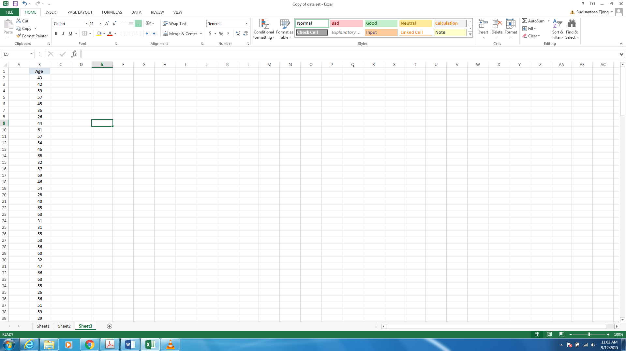
Table 1. The analysis on age
Once you have finished analysing ‘age range’ and ‘salary’ separately, you should group the date on each variable (‘age range’ and ‘salary’) based on a campus. For example, you should have 3 groups for ‘age range’ such as ‘age range’ for Singapore, Townsville and Cairns and 3 groups of ‘salary’ as well. Then you have to perform coefficient of variation for each group for example, coefficient variation for ‘age range’ in Singapore, ‘age range’ in Townsville, ‘age range’ in Cairns and others groups. When you calculate coefficient of variation, it means you should also find out mean and standard deviation. Table 2 shows the intended analysis. Then you should discuss the meaning of coefficient of variation for each location.
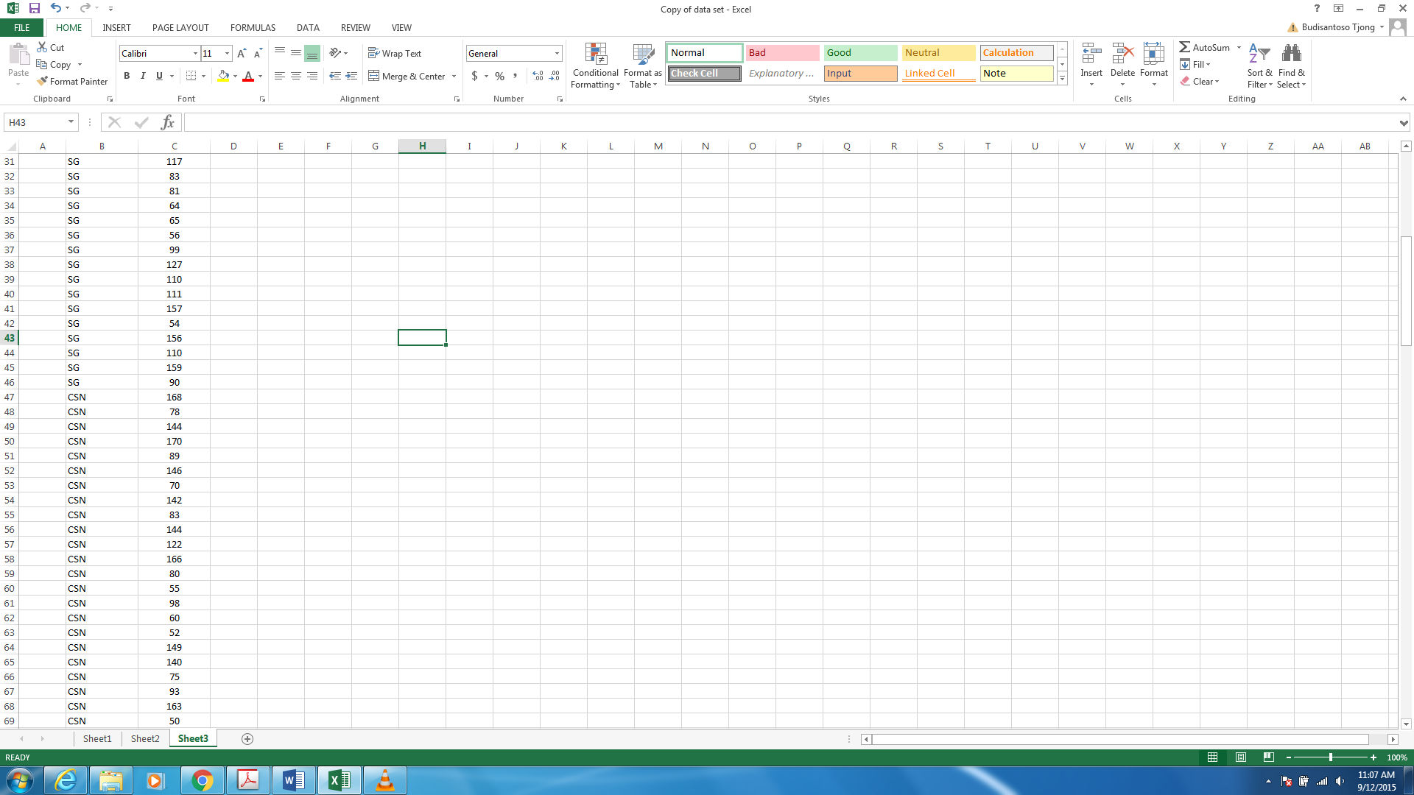
Table 2. Salary for each location

Number two
There are three joint information that you should provide. The first joint information is ‘employment type’ and ‘salary’. Please be aware with the scale of measurements for each of these variables. You have to separate the employment type into three groups, full-time, part-time and casual with their respective salaries. Table 3 shows the intended analysis.
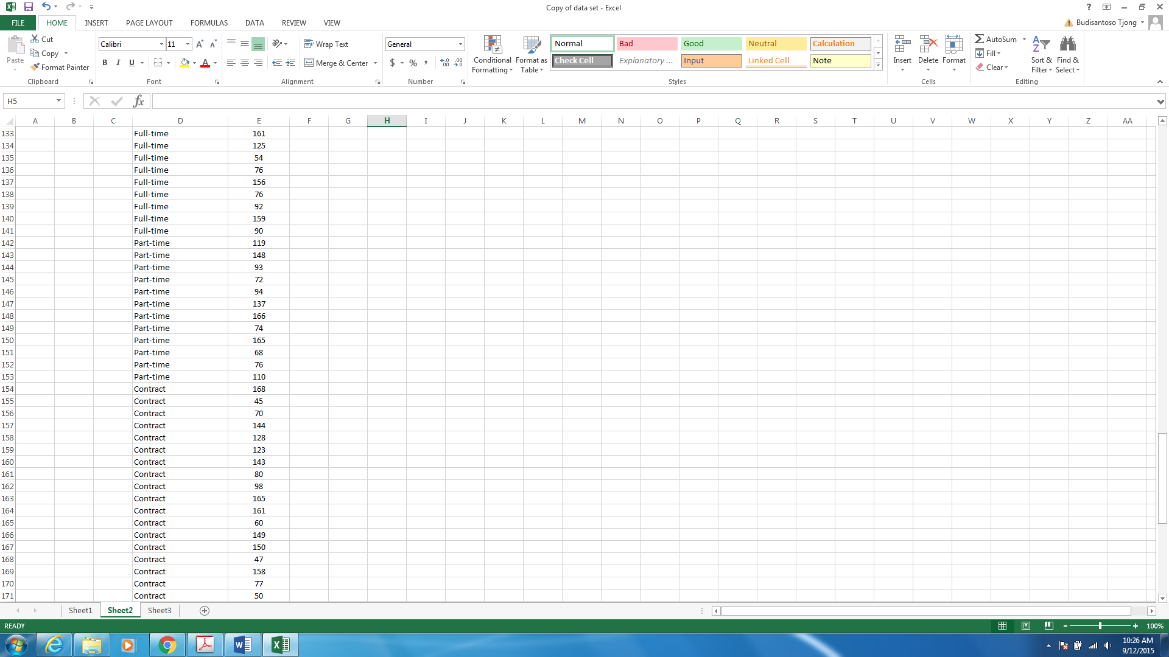
Table 3. The analysis on ‘employment type’ and ‘salary’

After you separate employment type into three groups with their respective salaries, you have to perform descriptive statistics for each group. You have to choose an appropriate descriptive statistics based on the scale of measurement. Then you should compare and contrast descriptive statistics on each group.
The second joint information is ‘age’ and ‘salary’. Again please be aware with the scale of measurement. You could either organize ‘age’ into ranges or perform a correlation analysis and provide correlation coefficient for each group. If you perform a correlation analysis, you can separate ‘age’ into three groups based on campus, Singapore, Townsville and Cairns and perform the analysis on each campus. At the end, you should compare and contrast the ‘age’ range or correlation coefficient at each campus.
The third joint information is ‘gender distribution’ and ‘type of employment’. Please be aware with the scale of measurement. You have to separate the data into two groups, male and female with their respective ‘type of employment’. You should analyse each group, using an appropriate descriptive statistics. Then you should compare and contrast the descriptive statistics on each group.
Number three
You should provide a relevant table or chart for:
- ‘age range’
- ‘salary’
- ‘age range’: Singapore, Townsville and Cairns
- ‘salary’: Singapore, Townsville and Cairns
- ‘employment type’ and ‘salary’: full-time and salary; part-time and salary; contract and salary
- ‘age’ and ‘salary’: 1) ranges of age and respective salaries and 2) scatter plot and correlation coefficient for Singapore, Townsville and Cairns
- ‘gender distribution’ and ‘type of employment’: male and type of employment and female and type of employment

Number four and five: the questions are clear. Please put emphasize on the discussion of the meaning of the number and the implication to JCU.

